React.js

Assignment 9

Code:

Created cricketapp react project, inside src created ListOfPlayers.js and IndianPlayers.js.

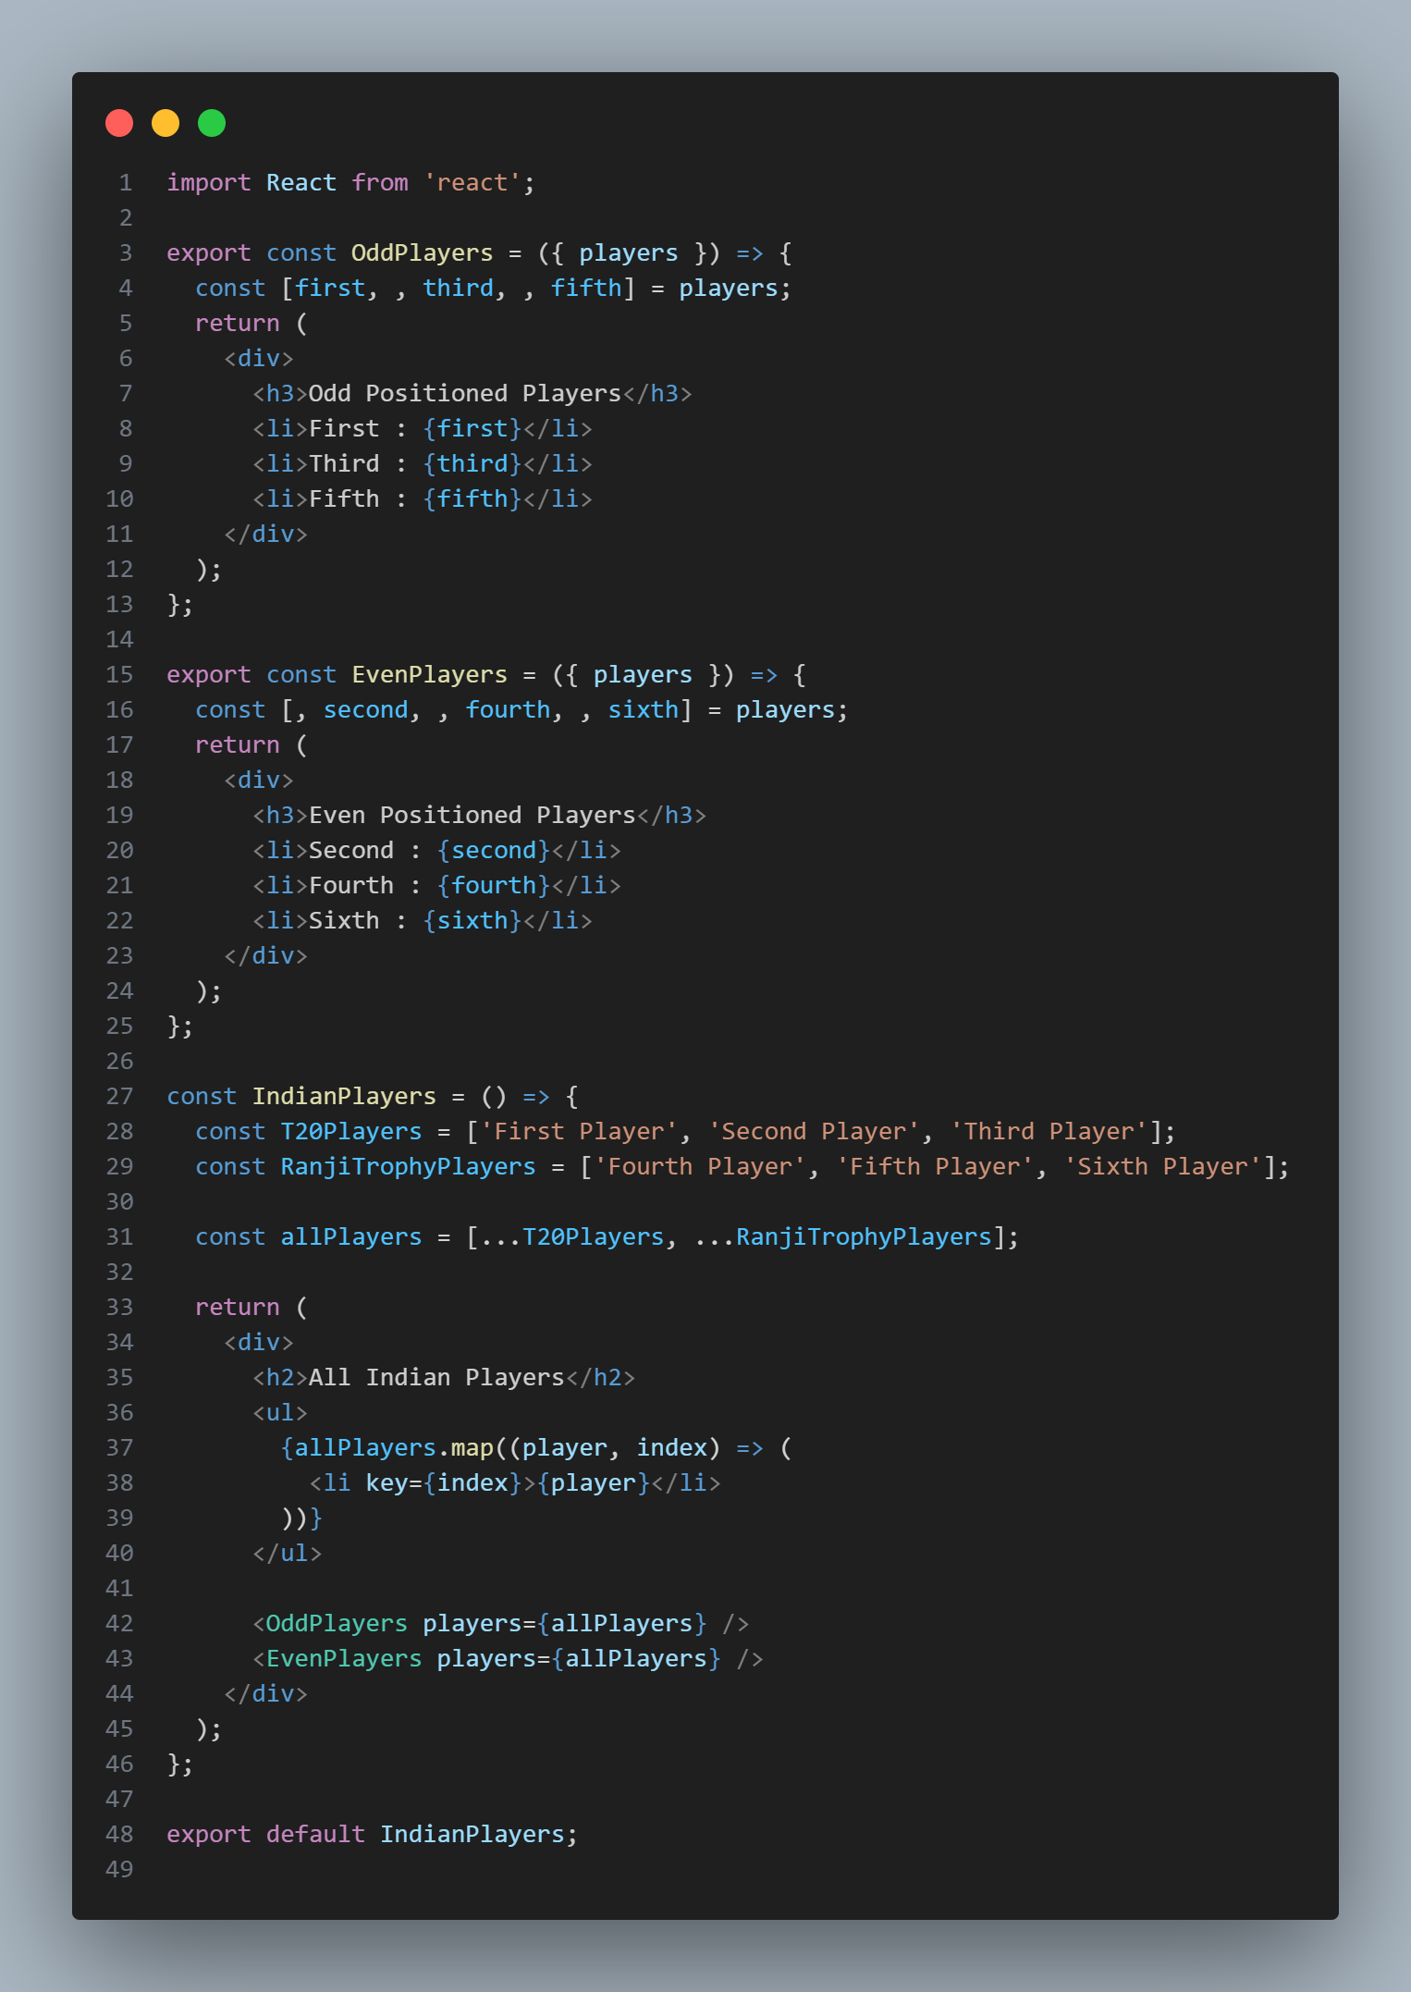IndianPlayers.js

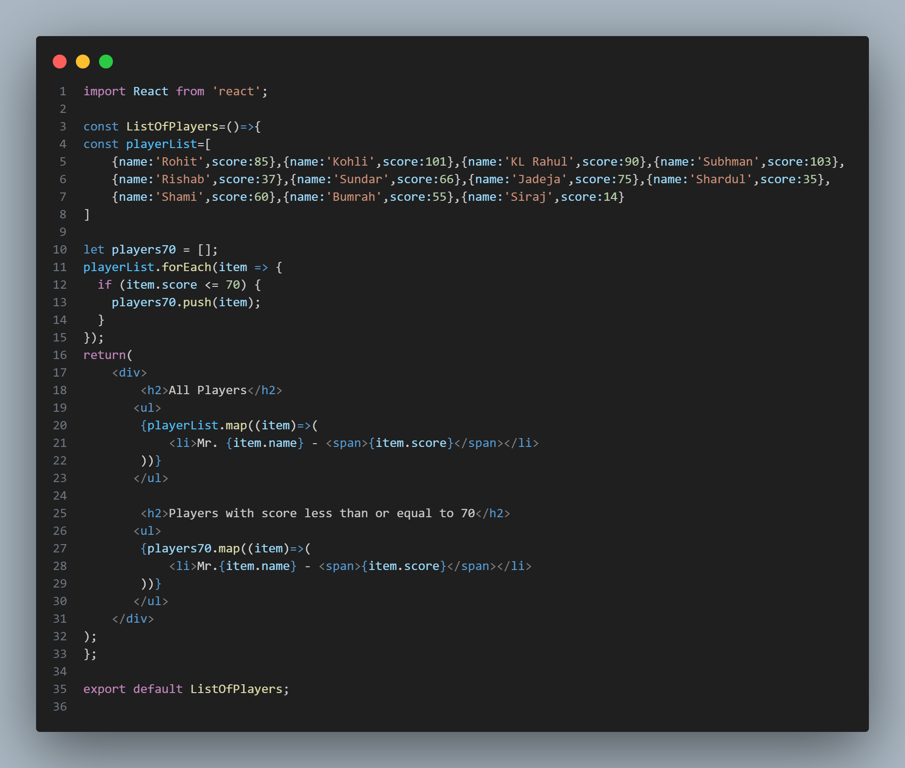AllPlayers.js

App.js, here the components are called and based on a flag variable the ListOfPlayers or the IndianPlayers component is rendered.

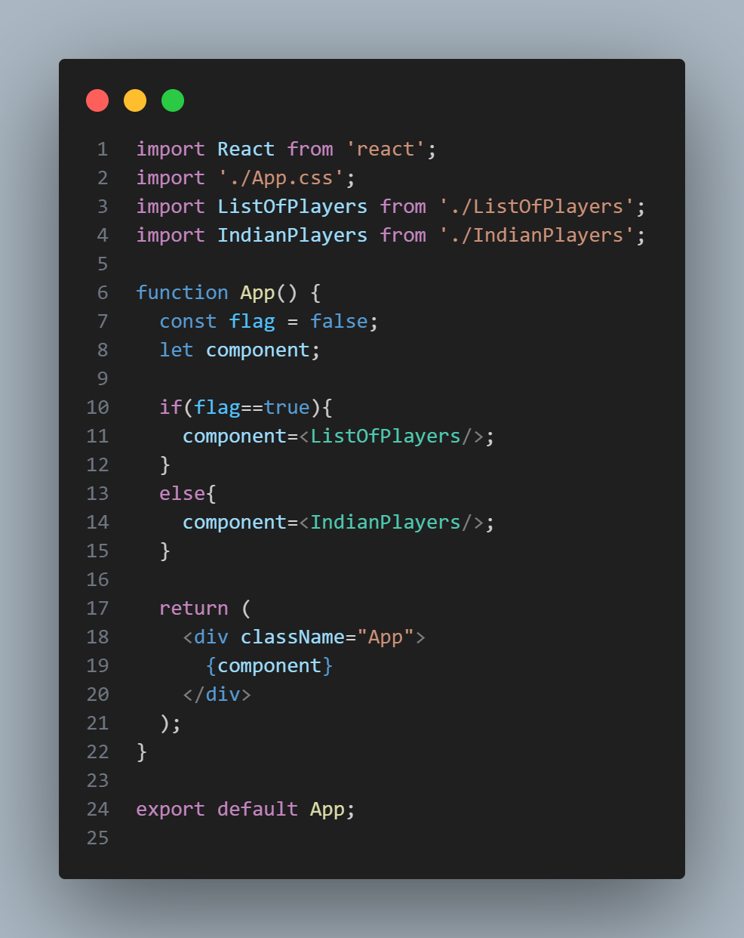

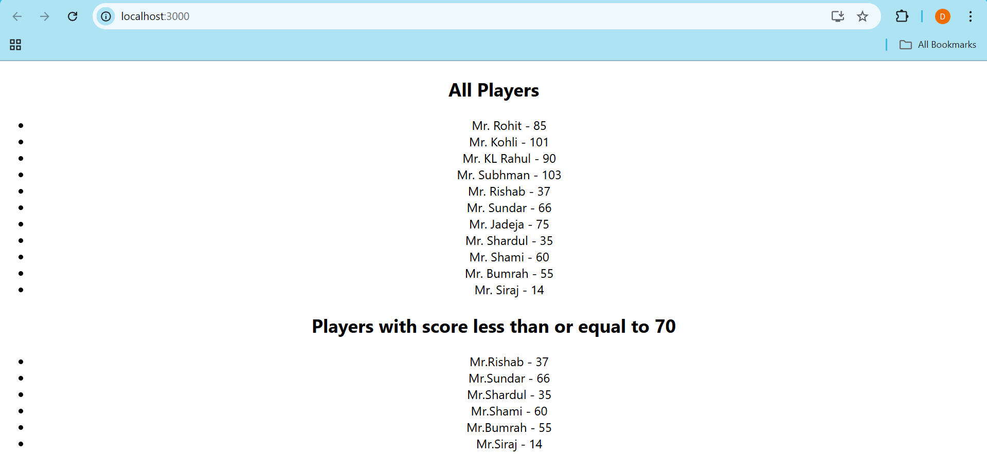Output:

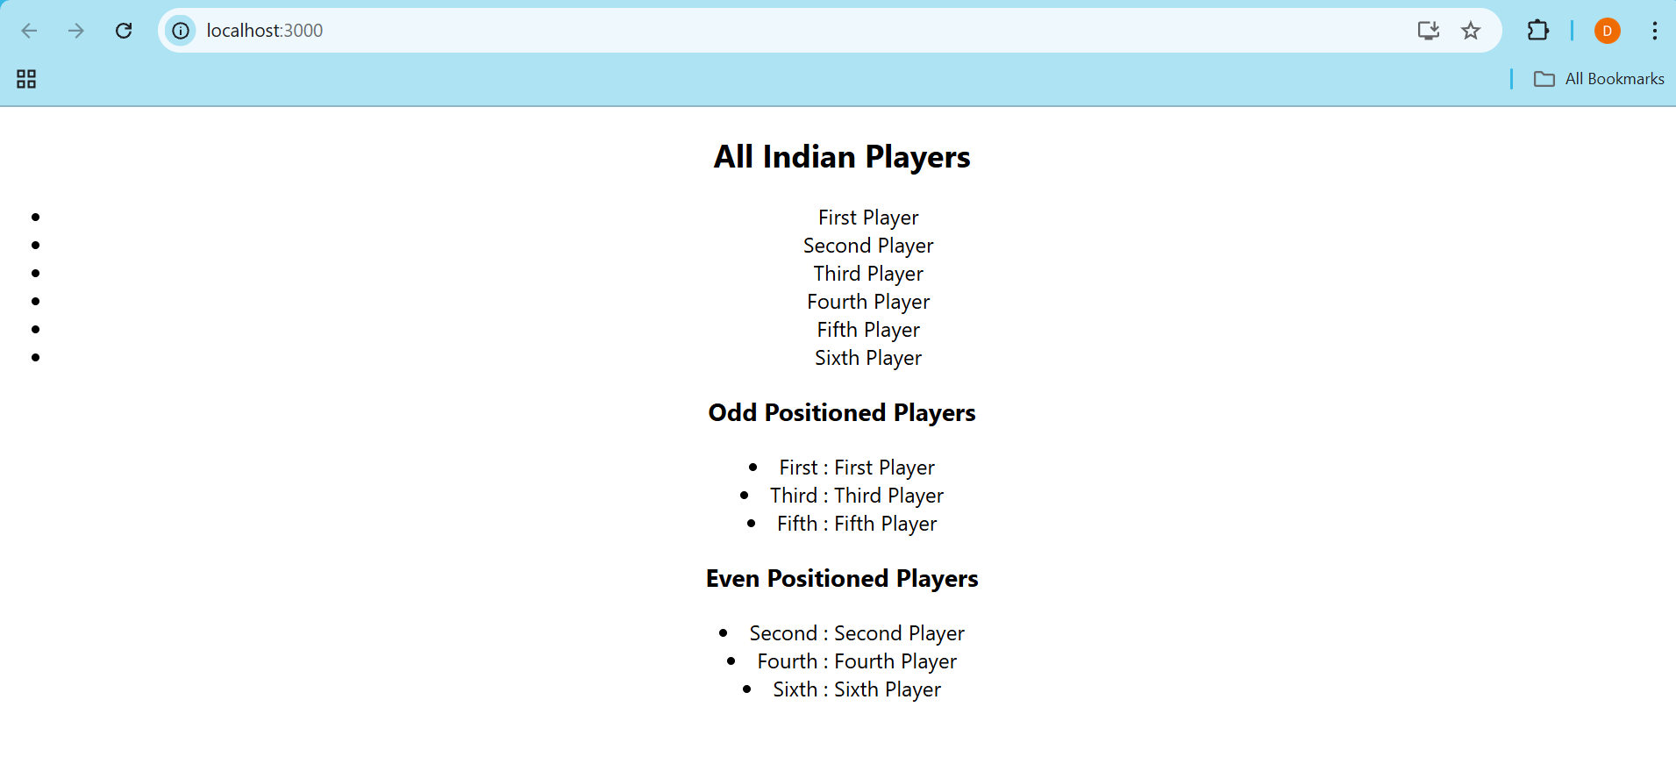

Assignment 10

Code:

Created officespacerentalapp project and inside src in the App.js file added the required code as mentioned in the assignment.

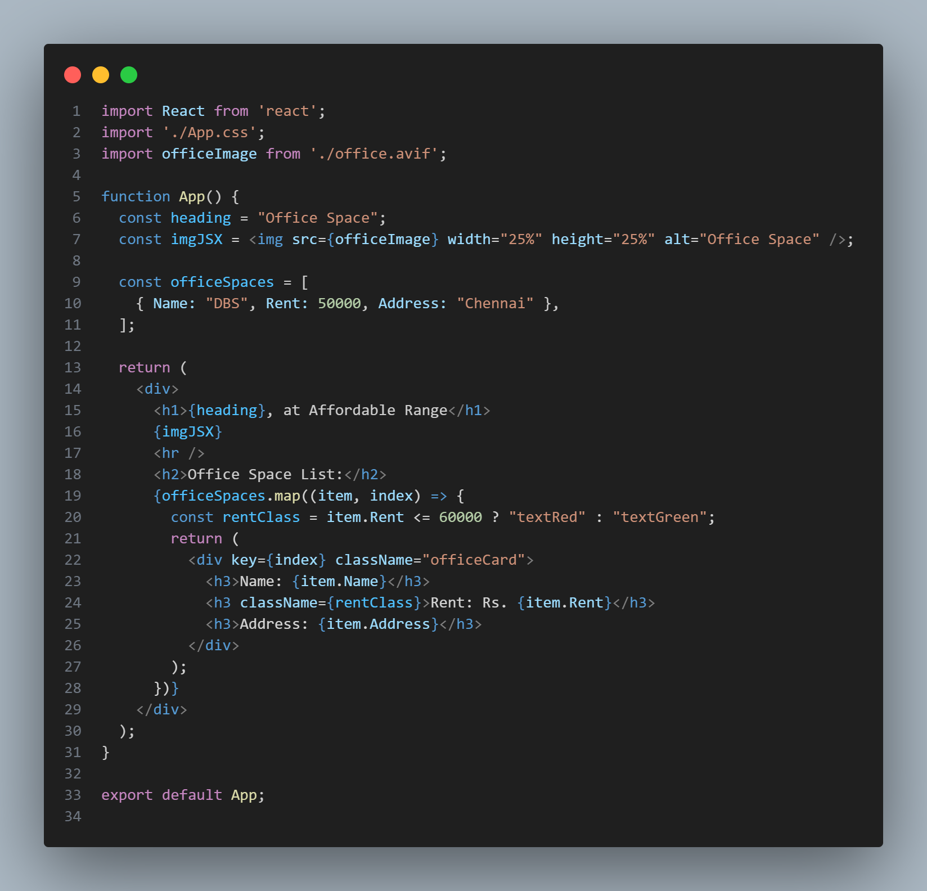App.js

Output:

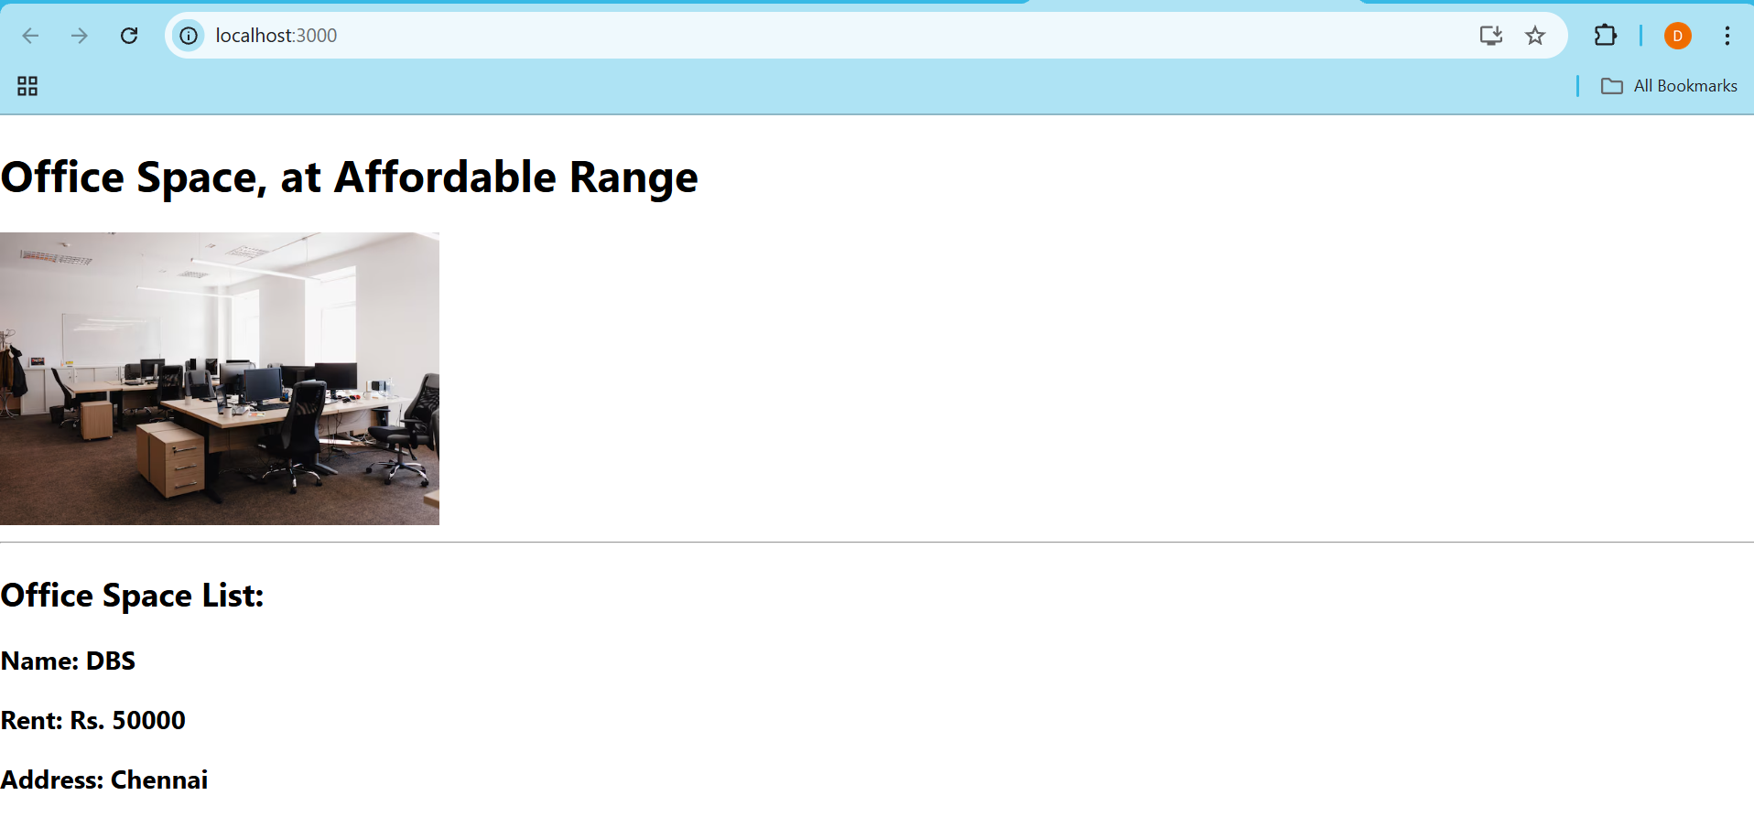

Assignment 11

Code:

Created eventexampleapp project and inside App.js added the varoius event handlers like useState, the various methods to handle the onclick actions of each button.

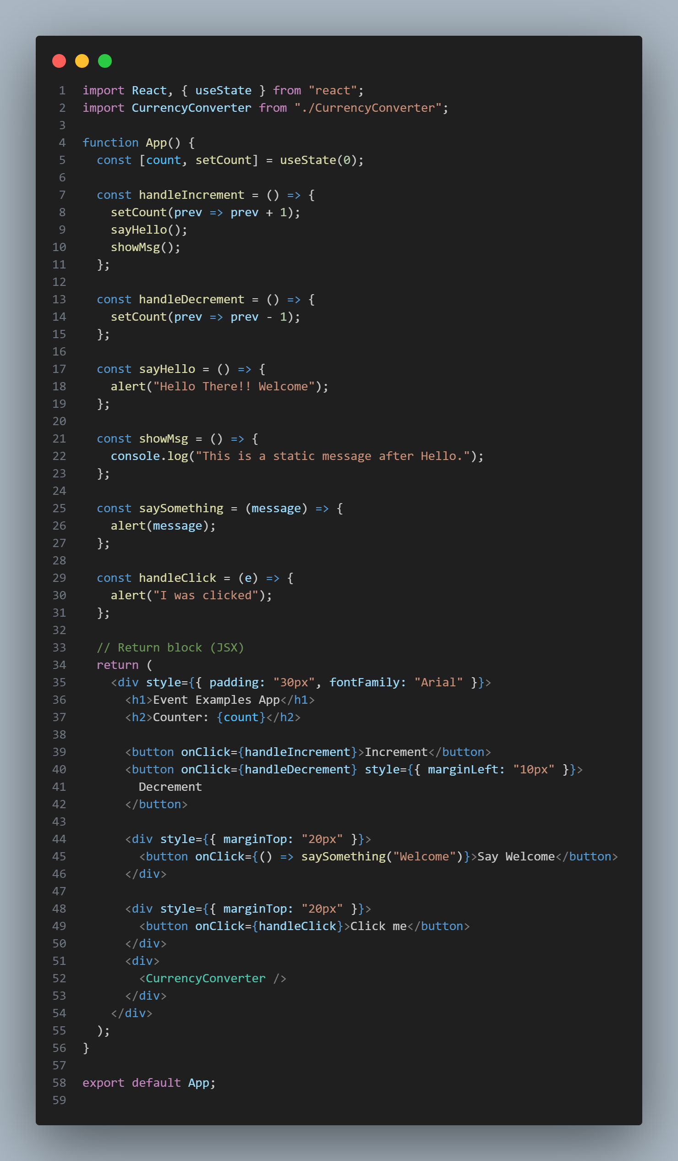App.js

App.js



Output:

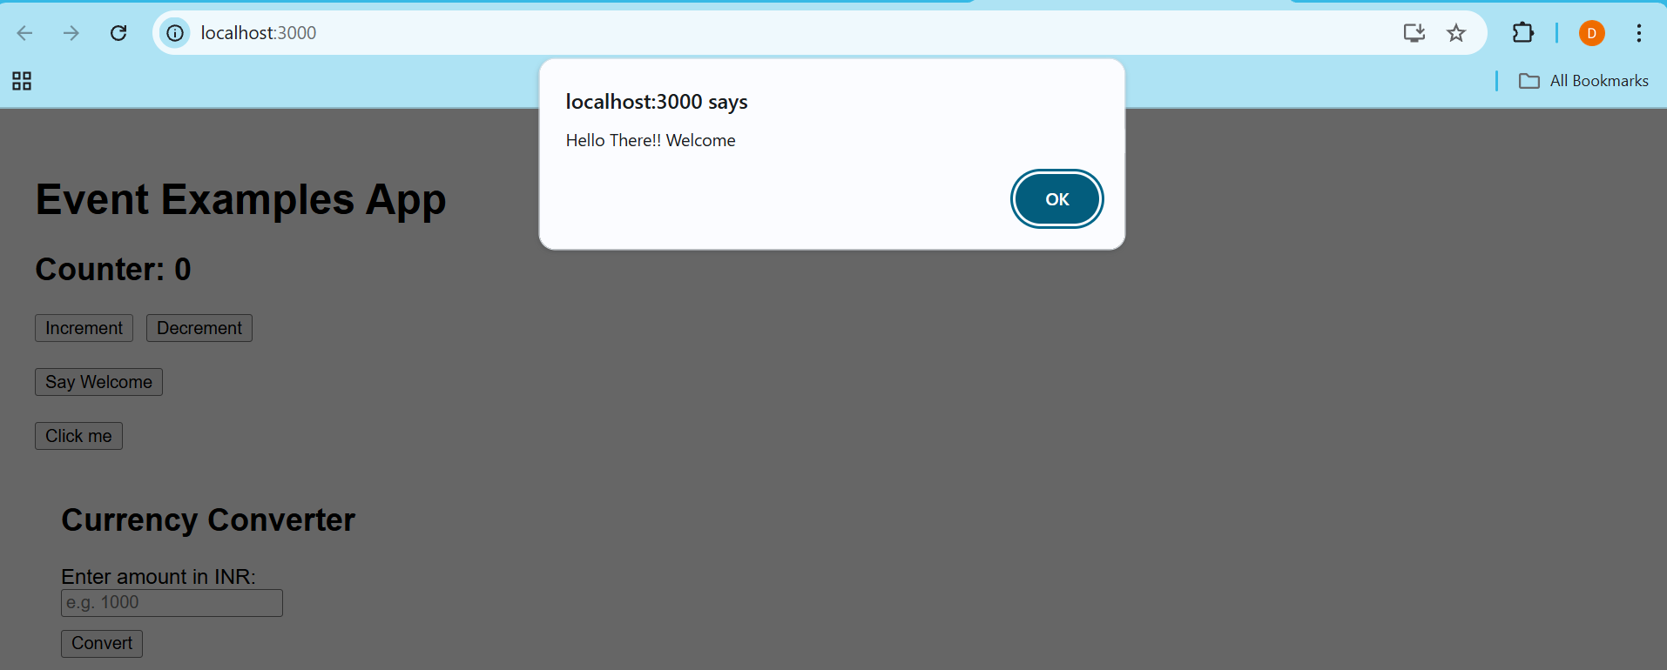

On clicking increment btn, the alert comes after that counter increments by 1.

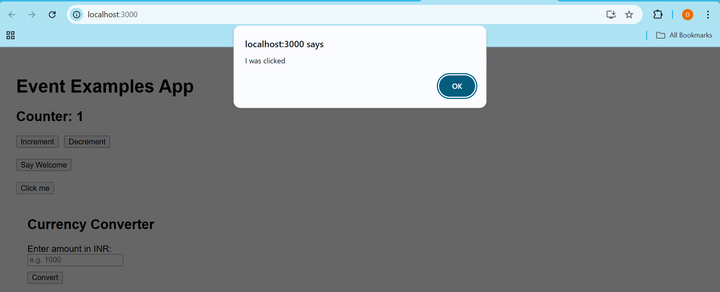On clicking the Click me btn, the following alert comes.

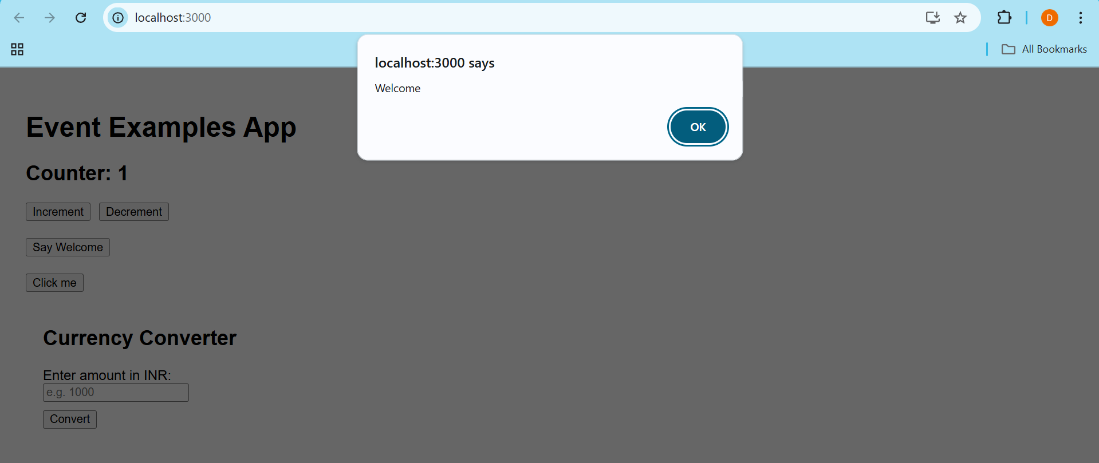

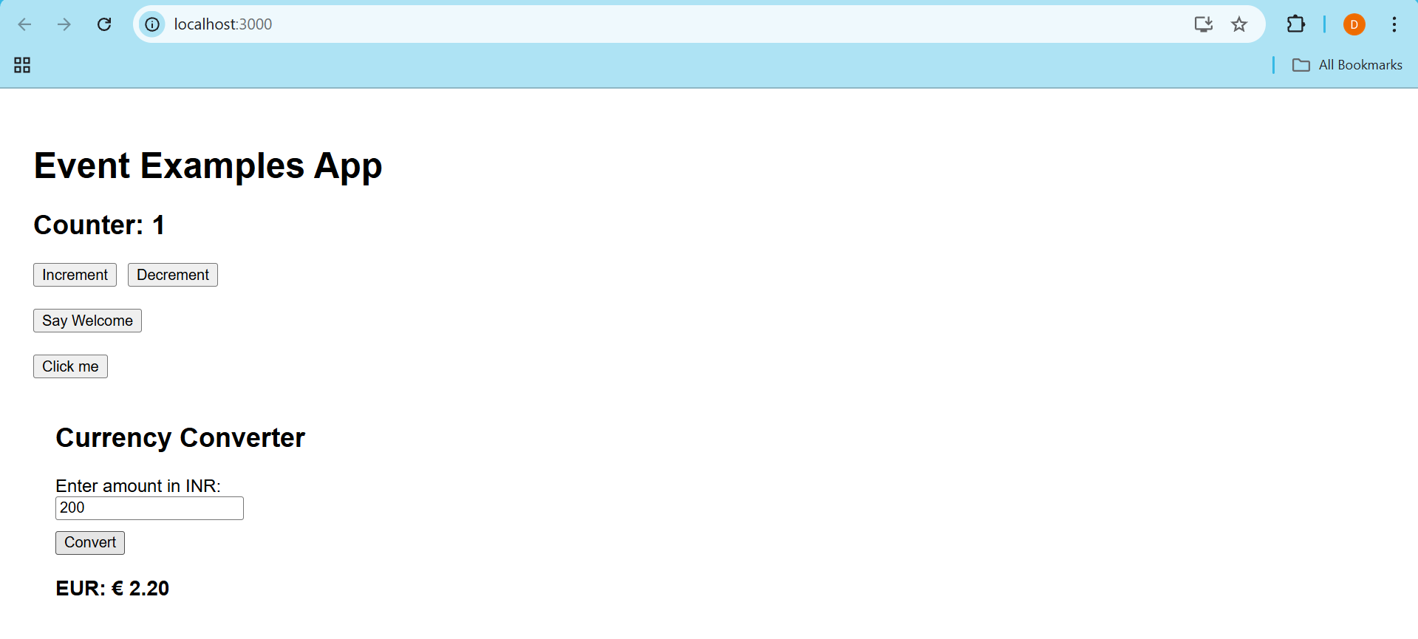On clicking Say welcome btn, the above alert comes.

On decrementing from 2 Counter becomes 1 when Decrement btn is clicked.

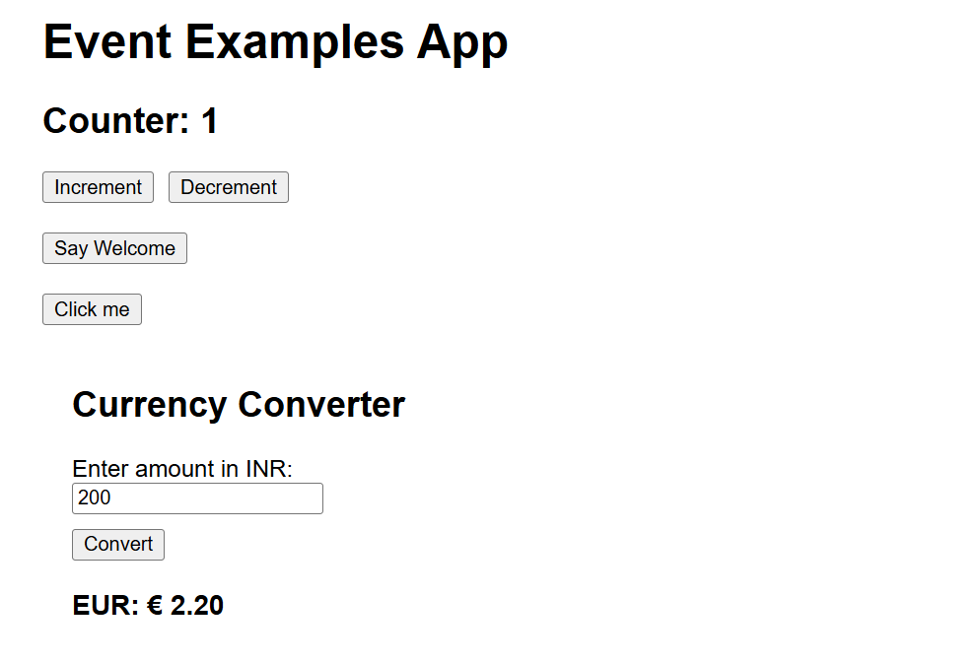

The Currency converter converts the INR to Euros.

Assignment 12

Code:

Created ticketbookingapp and inside components folder created UserPage.js, UserGreeting.js, LogoutButton.js, LoginButton.js, GuestPage.js, GuestGreeting.js, Greeting.js FlightList.js components.

UserPage.js

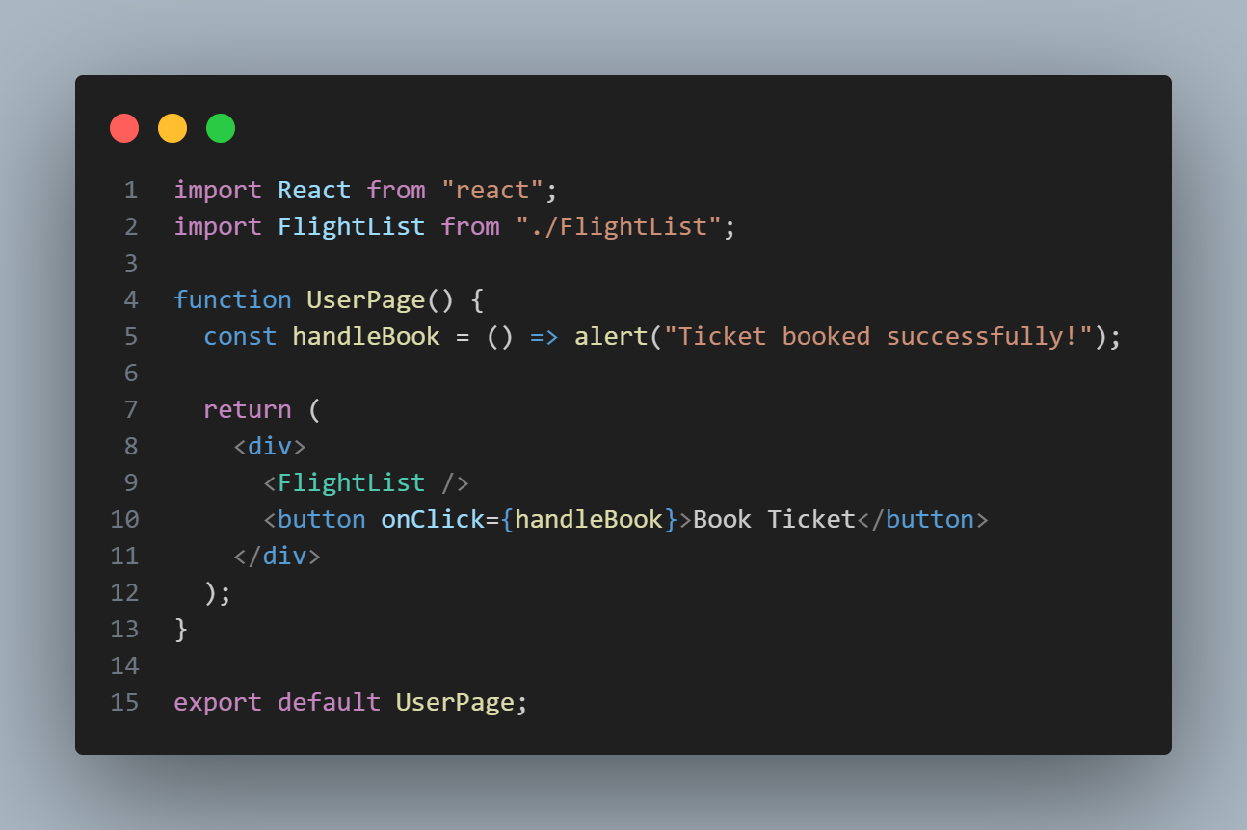

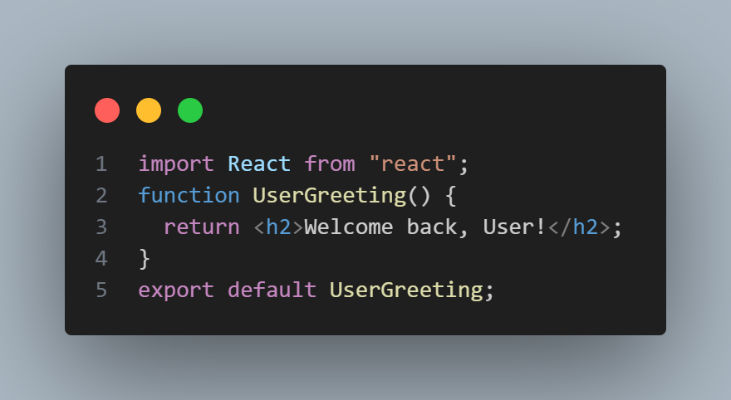UserGreeting.js

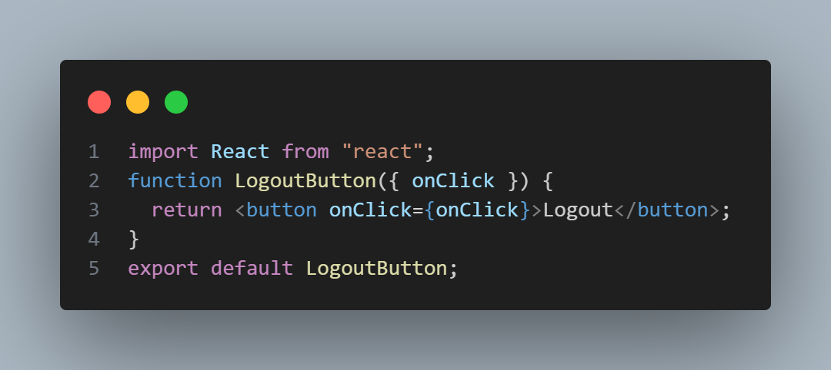LogoutButton.js

LoginButton.js

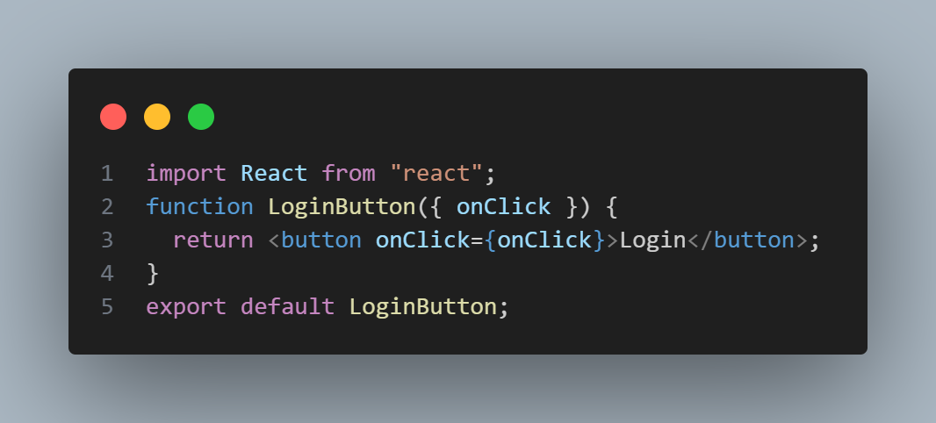

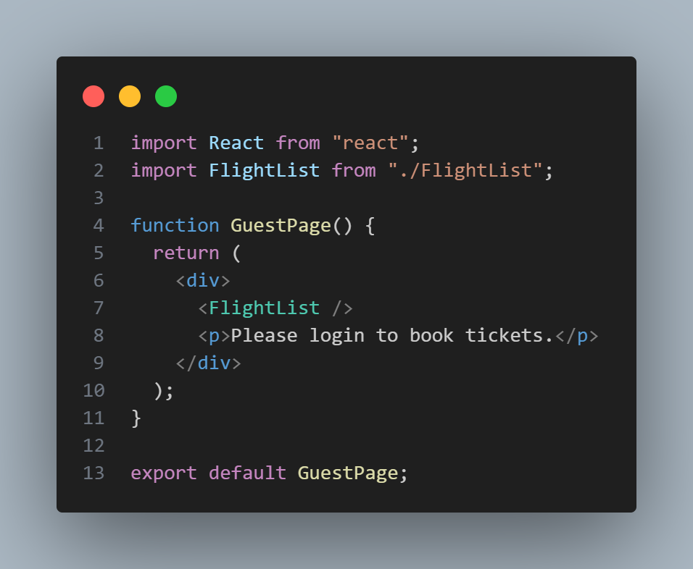GuestPage.js

GuestGreeting.js

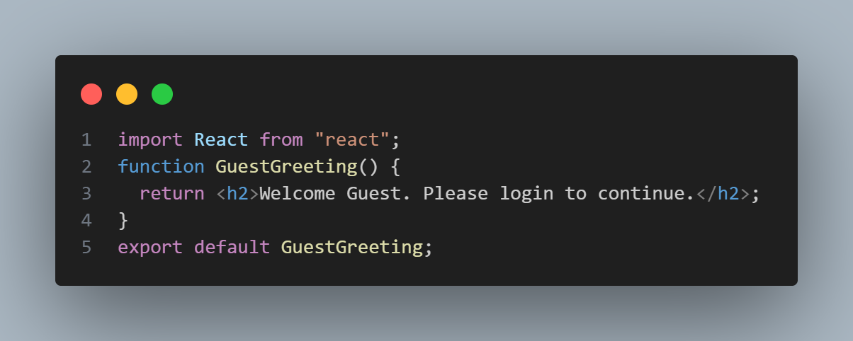

Greeting.js

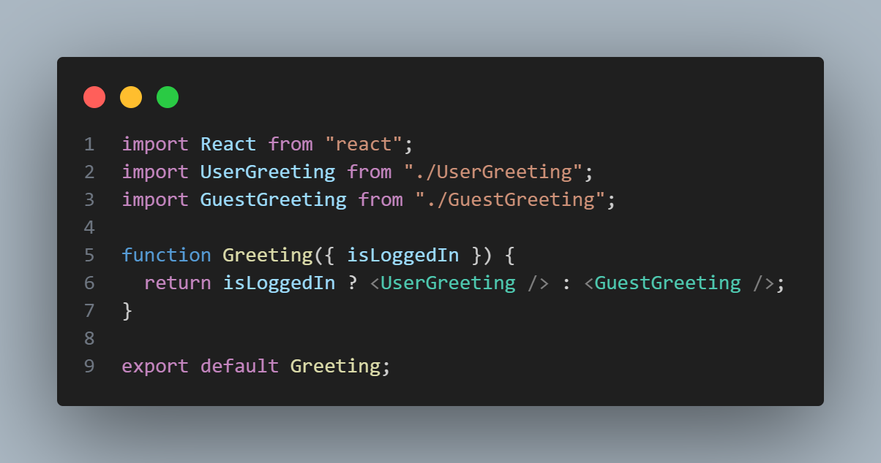

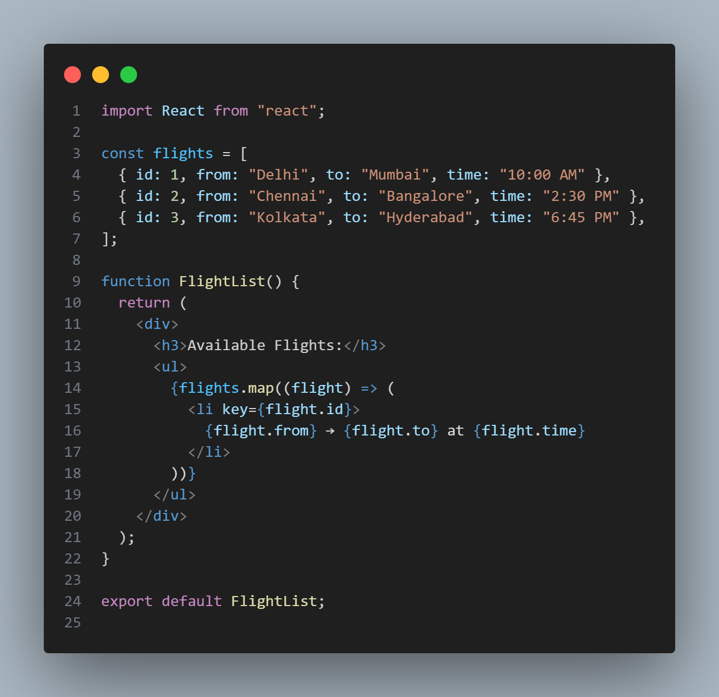FlightList.js

App.js

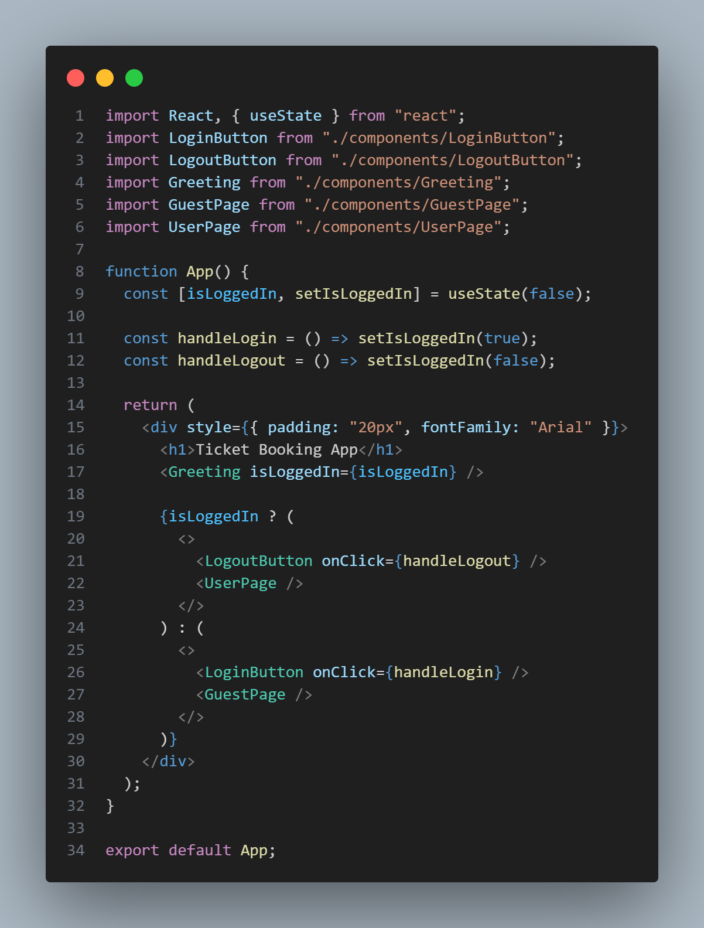

Output:

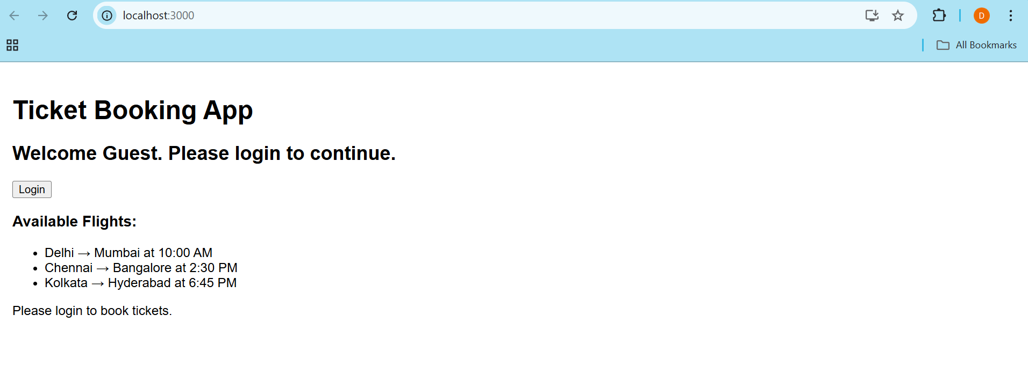

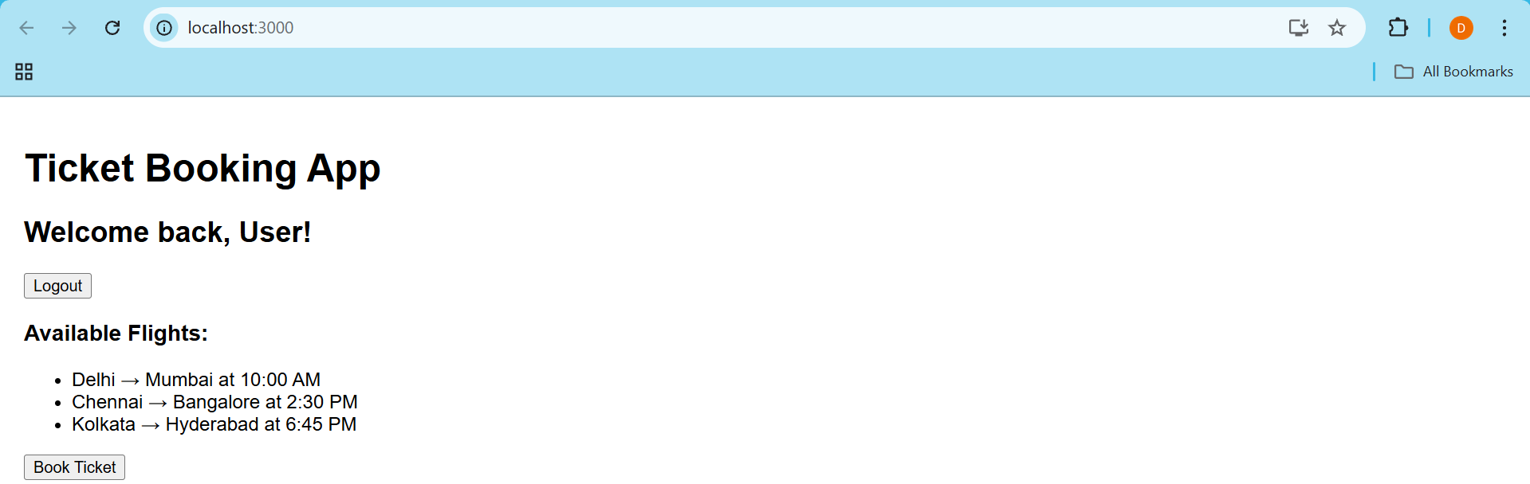

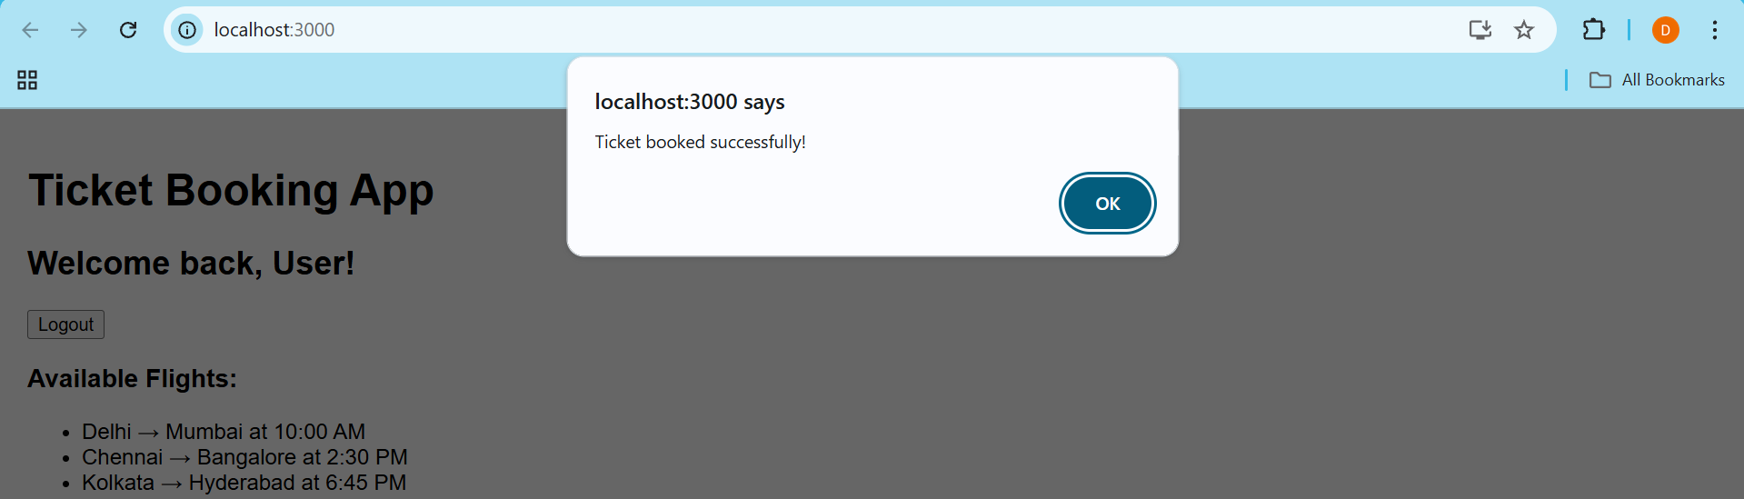

Assignment 13

Code:

Created bloggerapp project and inside src created BlogDetails.jsBookDetails.js and CourseDetails.js inside components folder.

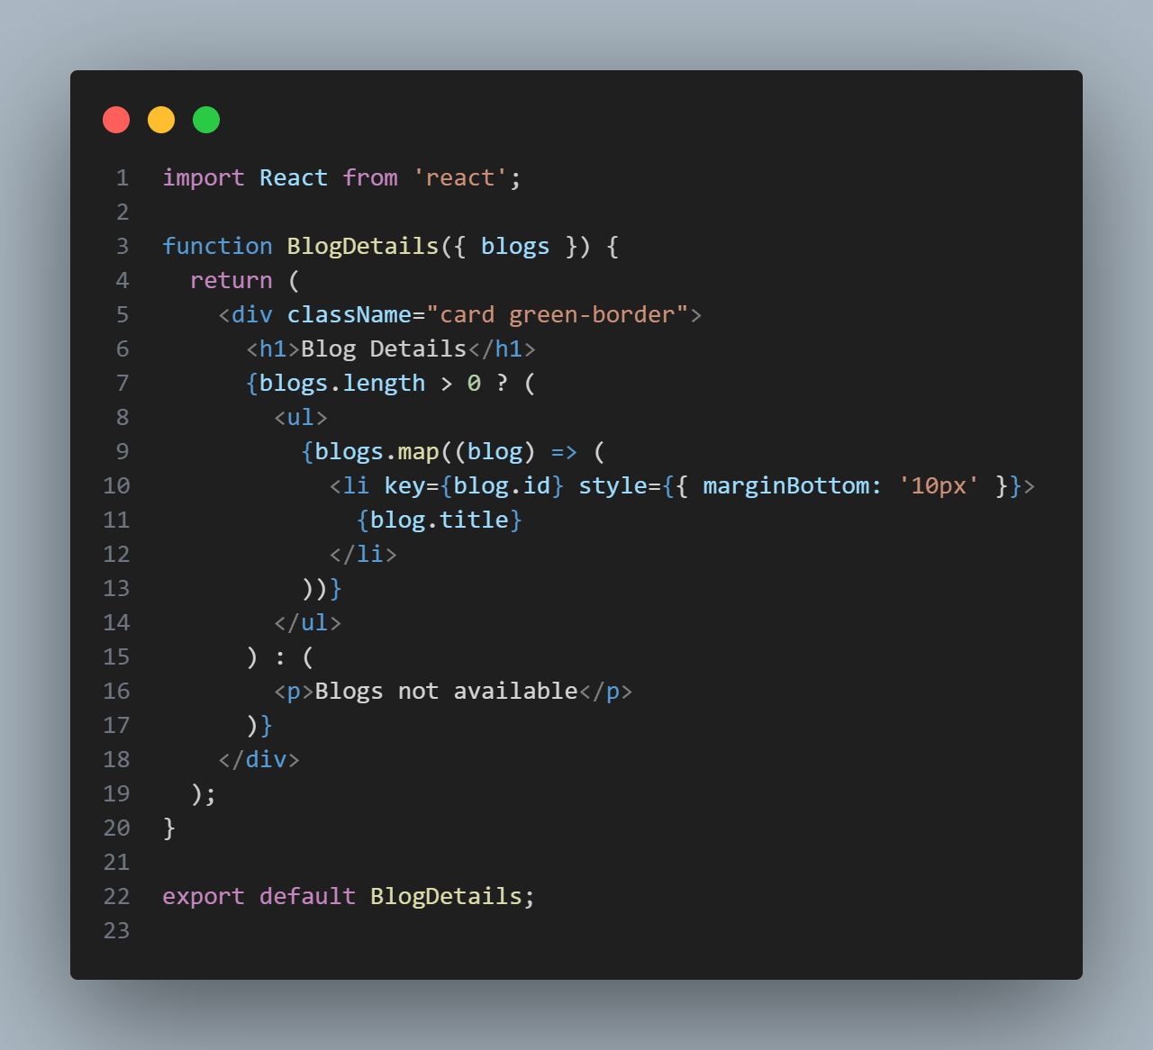BlogDetails.js

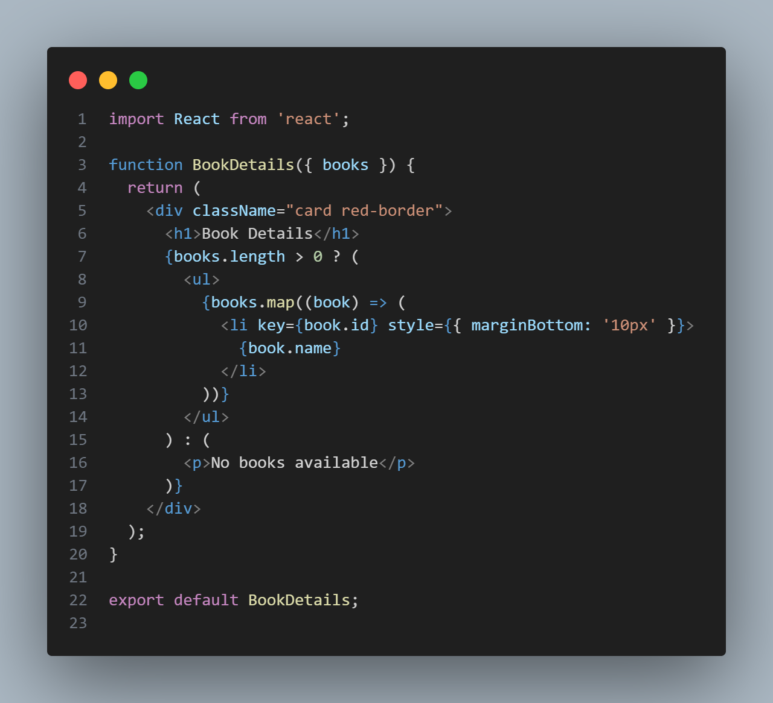BookDetails.js

CourseDetails.js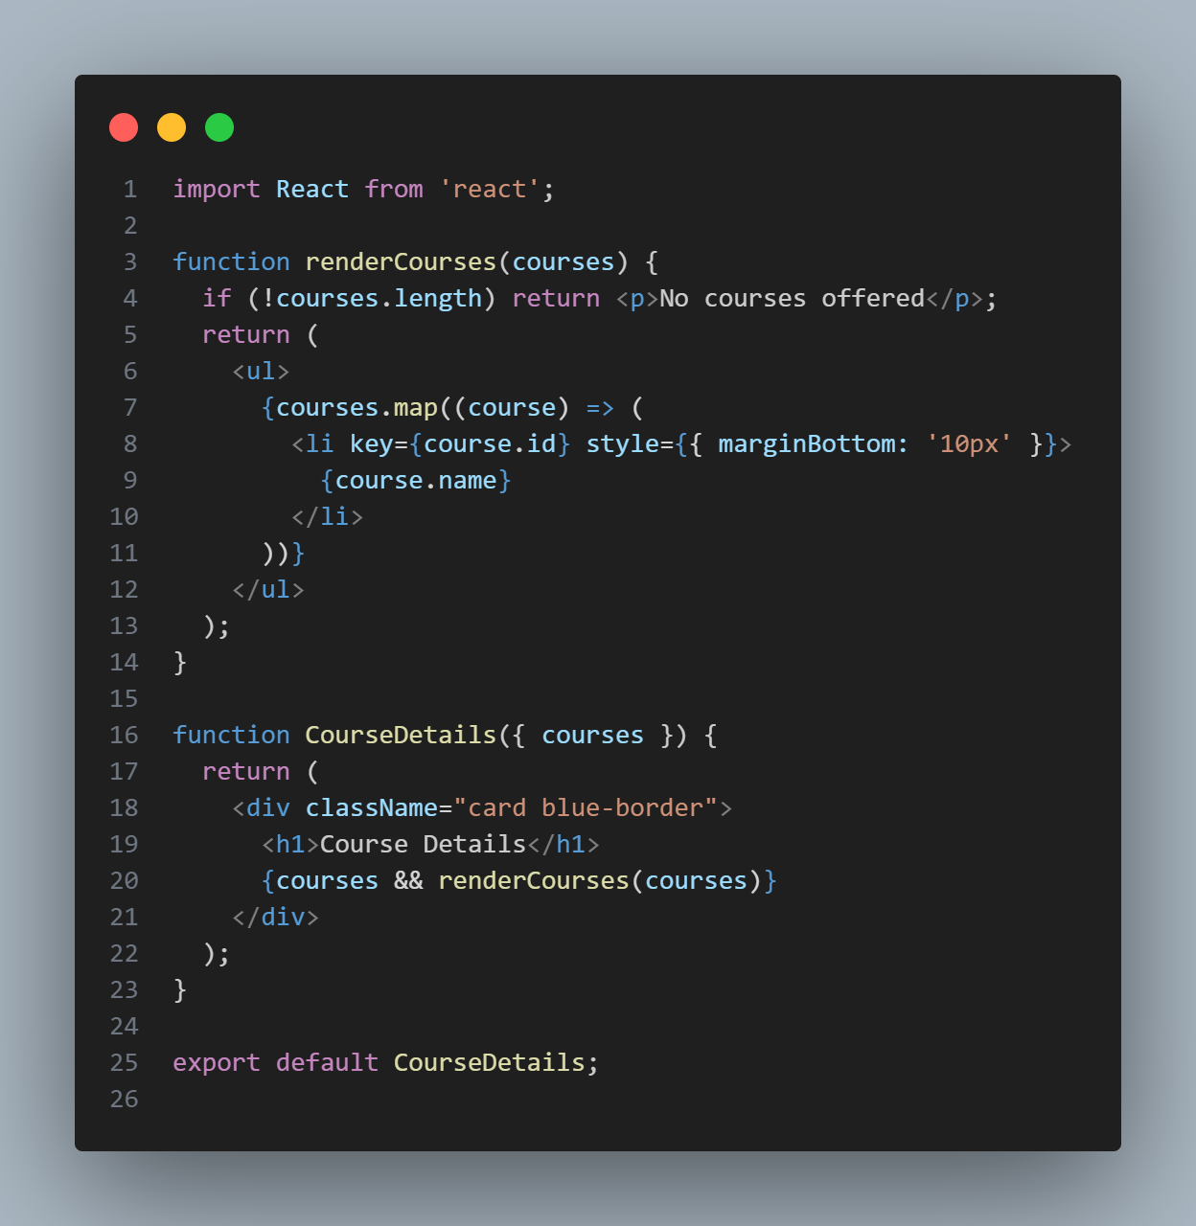

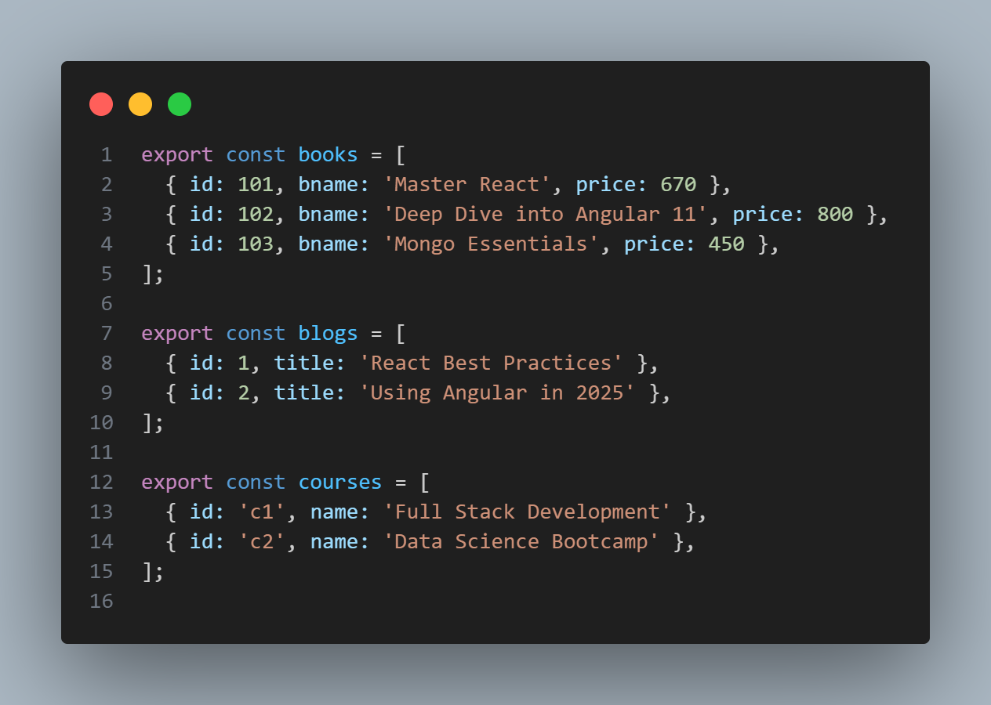

This is the data.js file containing sample data.

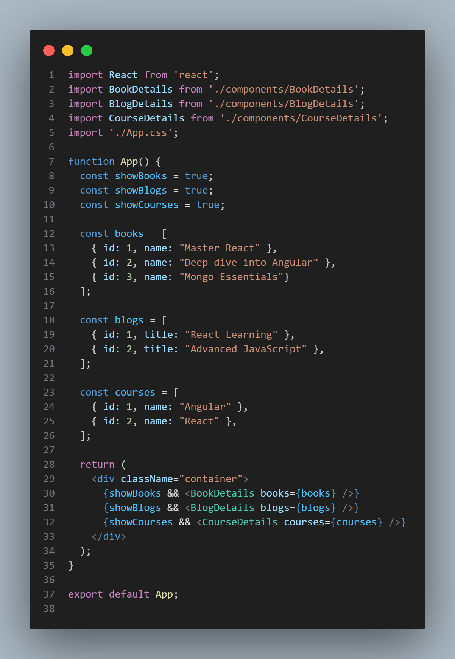App.js

App.css

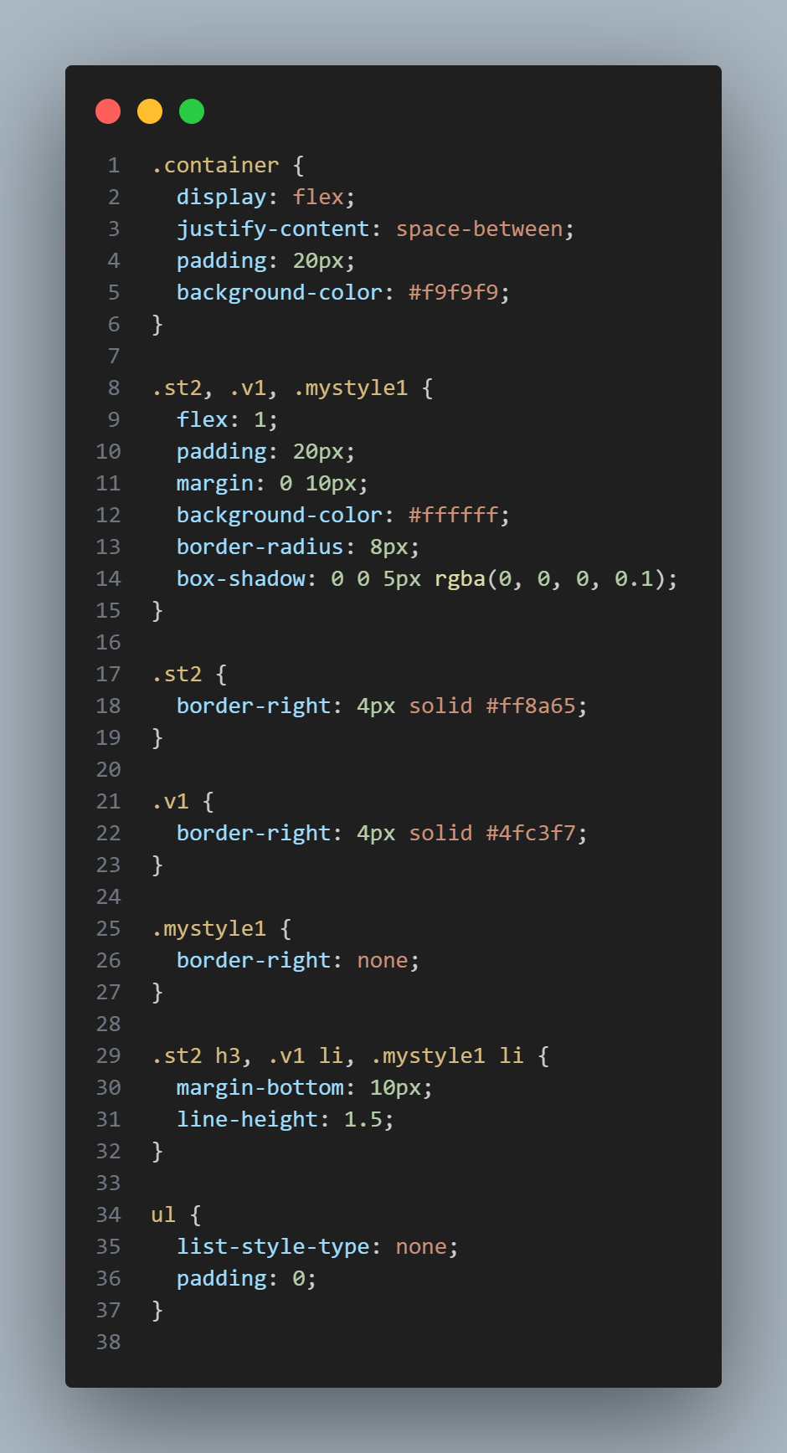

Output:

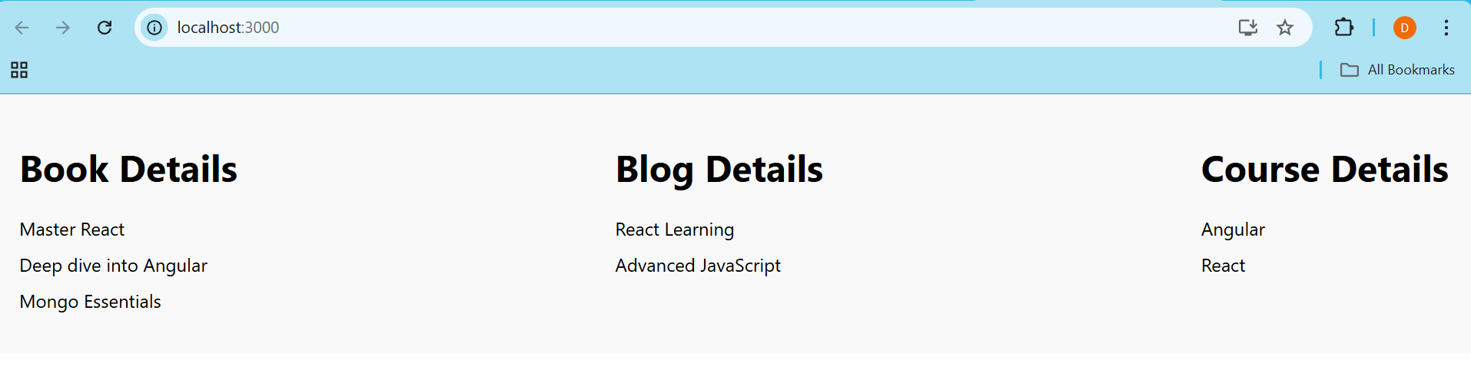

Application 14

Code:

Created employeesapp project and created EmployeeCard.js and EmployeeList.js files in src folder. Also created ThemeContext to toggle between light adark mode for the buttons.

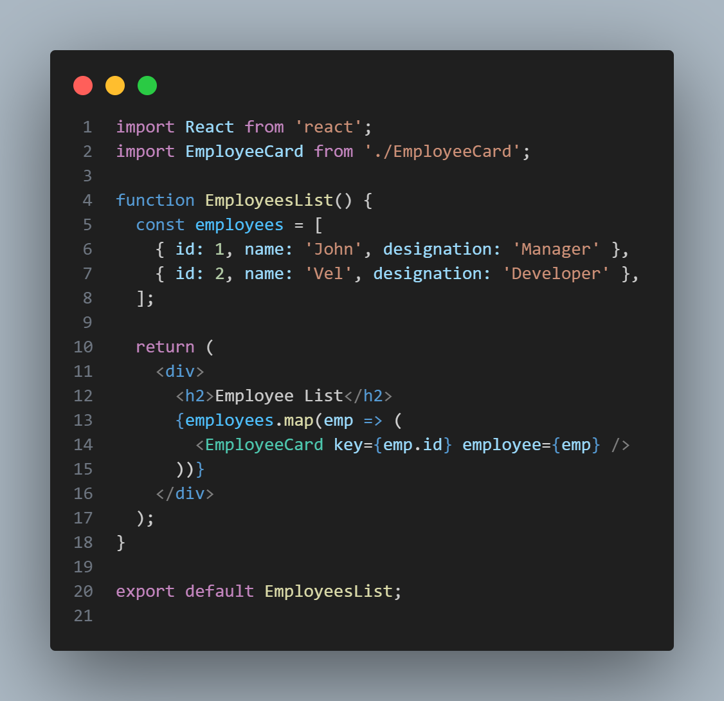

EmployeeList.js

ThemeContext.js

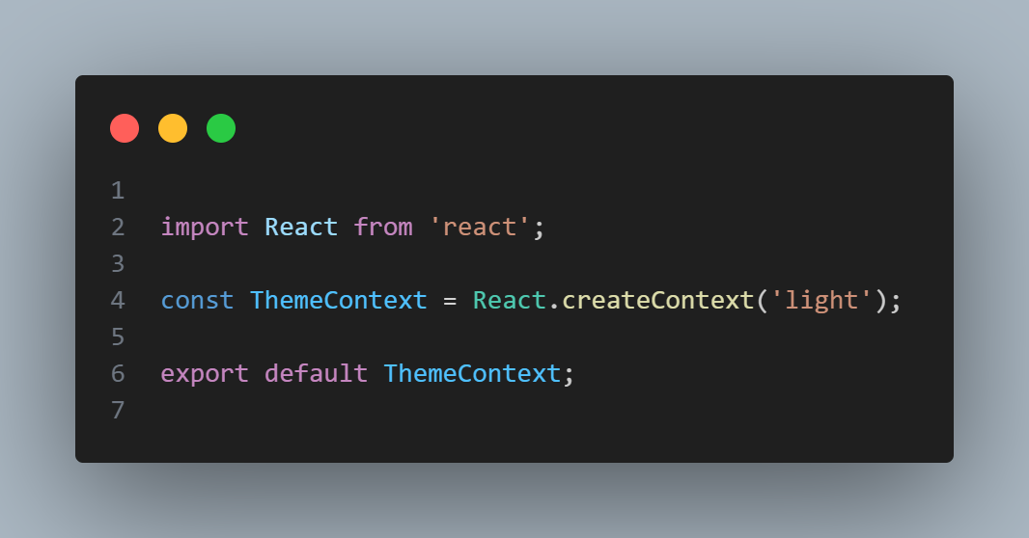

EmployeeCard.js

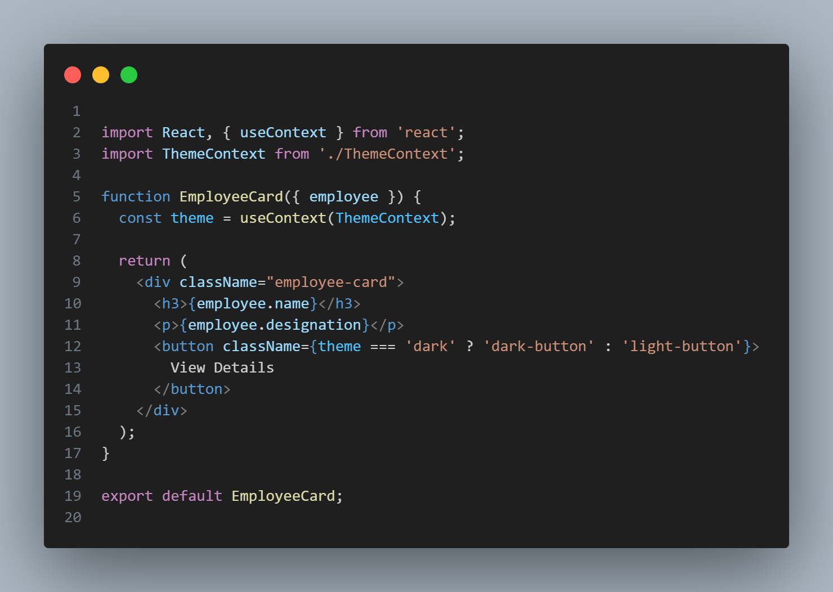

App.js

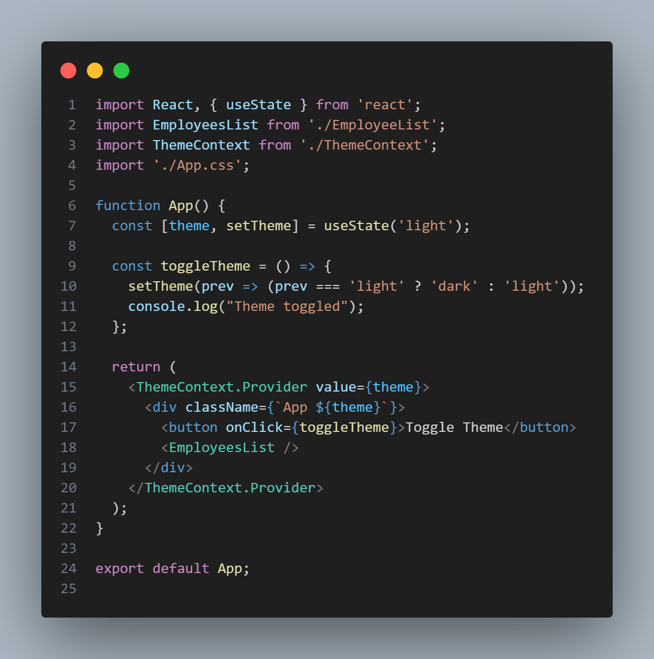

Output:

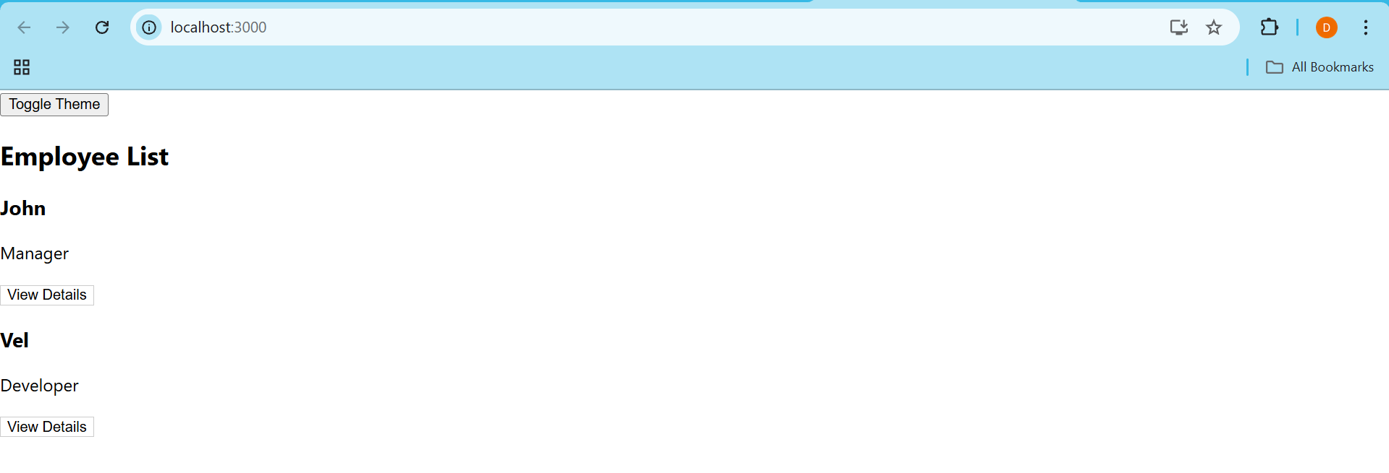Light Mode

Dark mode

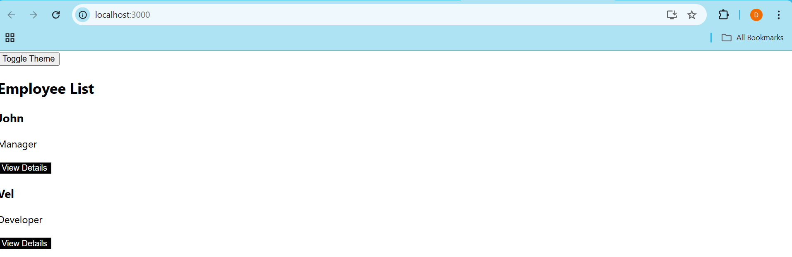

Assignment 15

Code:

Created ticketraisingrapp and inside src folder created ComplaintRegister.js

App.js

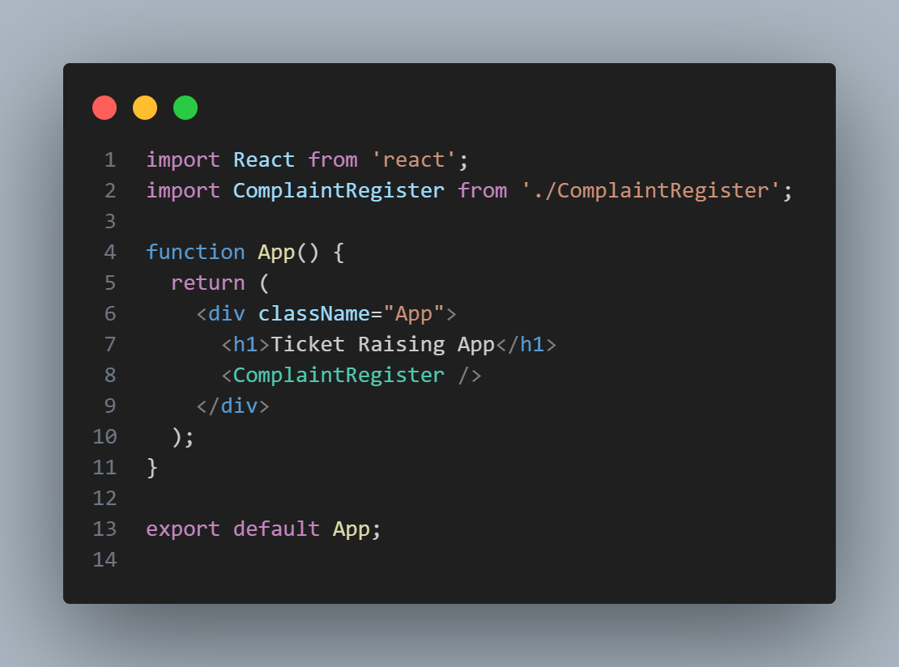

ComplaintRegister.js

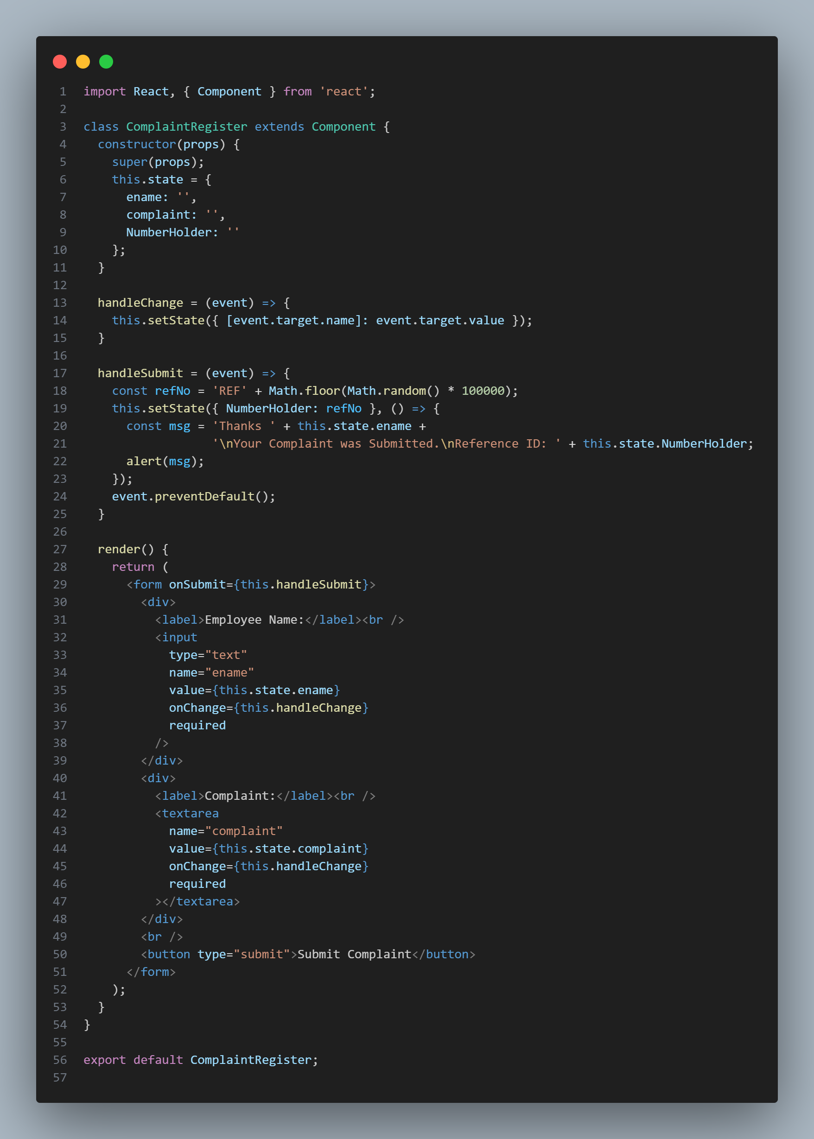

Output:

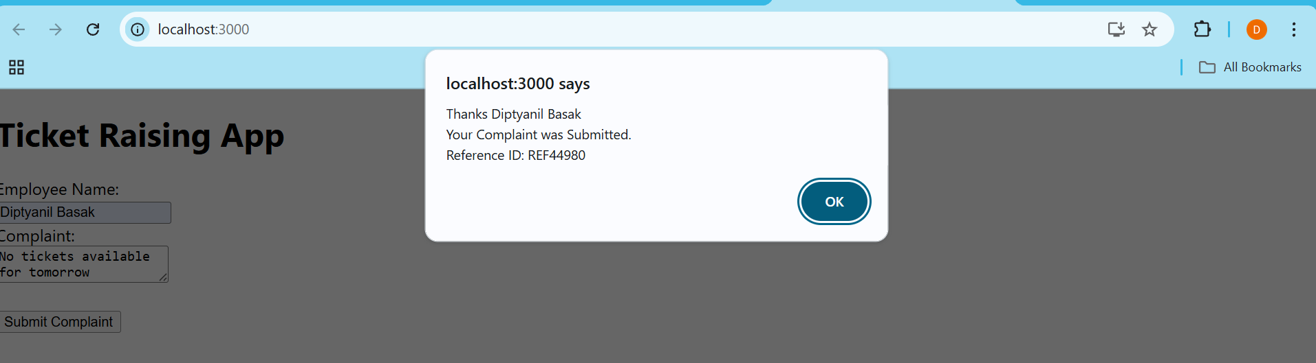

Assignment 16

Code:

Created mailregisterapp and inside src folder created Register.js

App.js

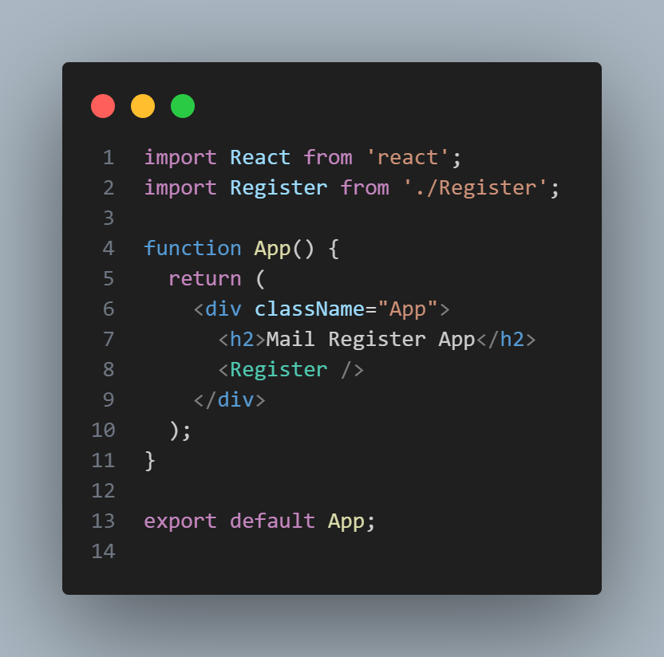

Register.js

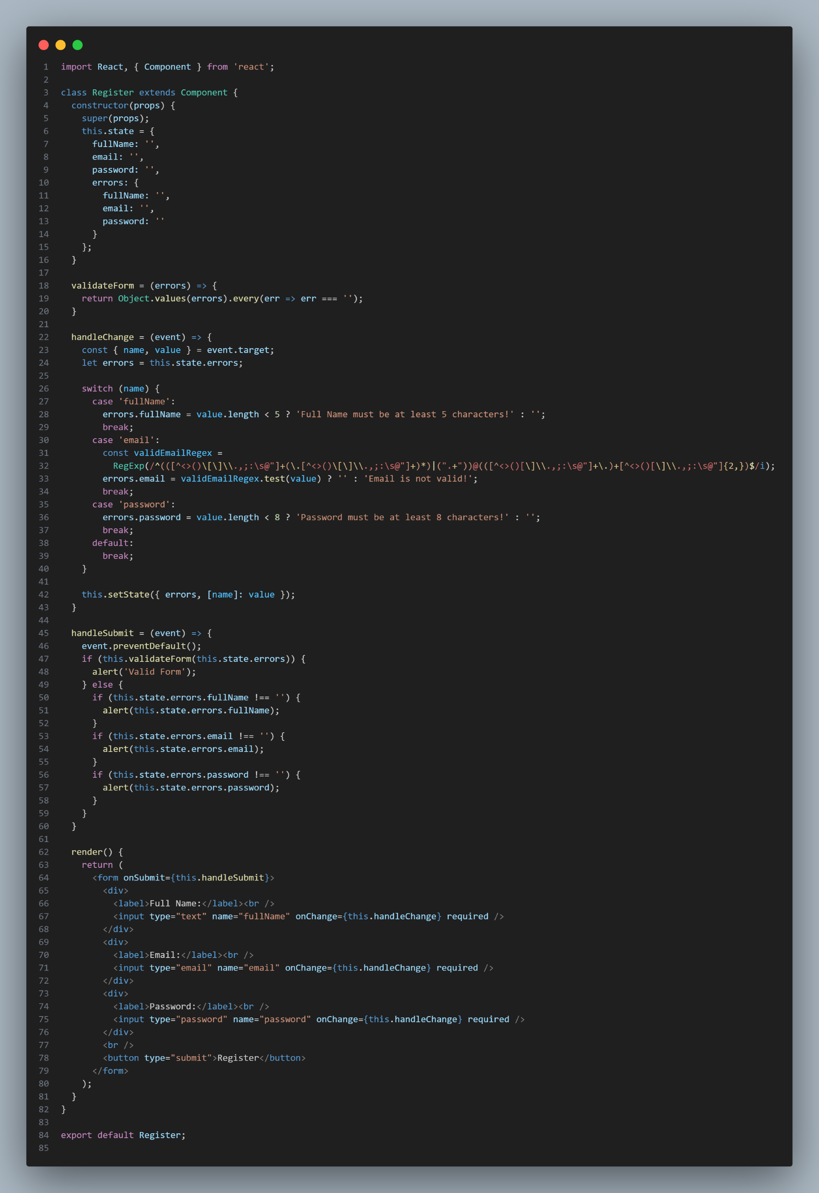

Output:

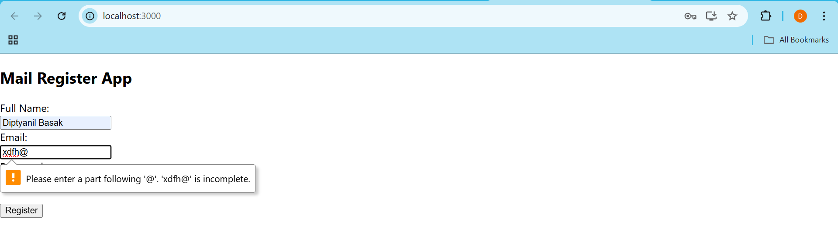

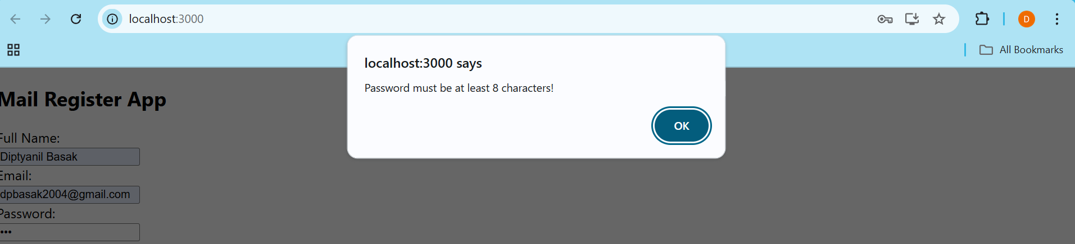

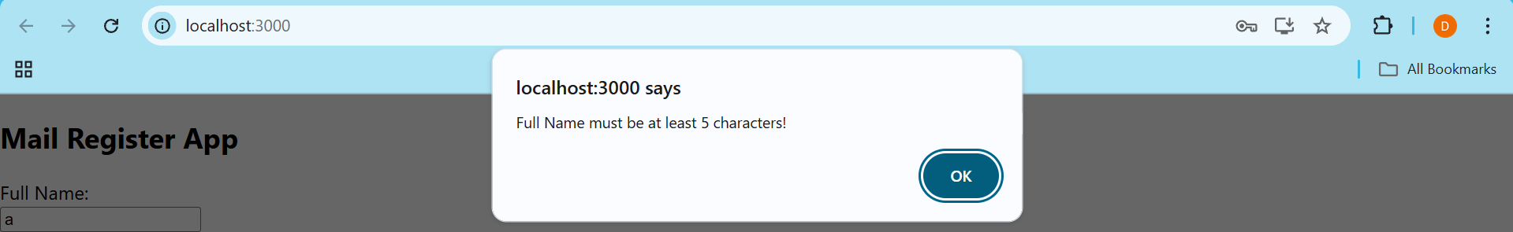

Assignment 17

Code:

Created fetchuserapp and inside src folder created GetUser.js

App.js

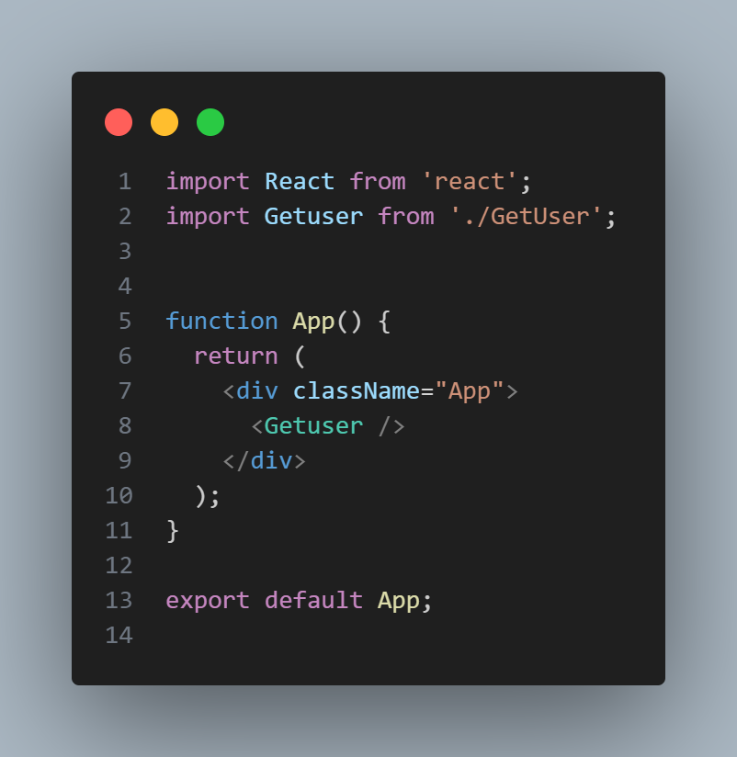

GetUser.js

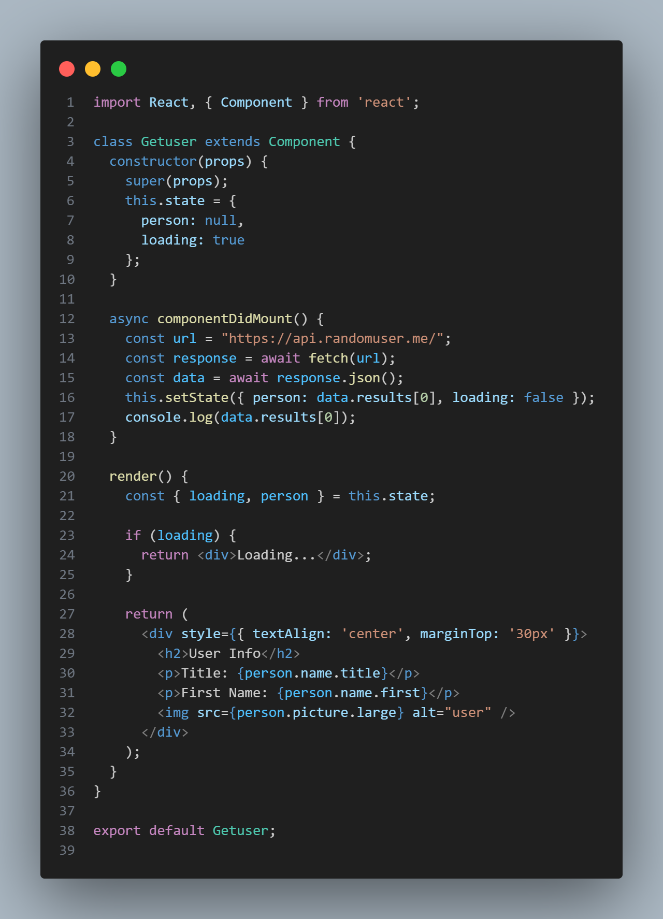

Output:

